Meigan First

John Sudds

Will Brown

Theme: We found a cool video showing how to make cool-looking broken, glitchy text, and based the theme around the idea of using that glitchy text. We are making a gothic looking gallery wall, with a horizontal scroll function. The text will be embedded in various picture frames along with other images to evoke that somewhat creepy, but mostly really cool gothic vibe that we are trying to achieve.

YouTube Inspiration video: <https://www.youtube.com/watch?v=7Xyg8Ja7dyY&list=WL&index=5>

Reference images :

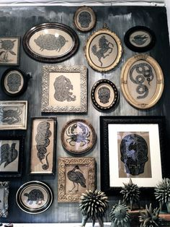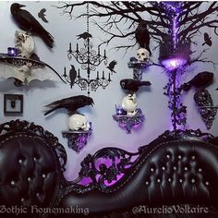

Possible Font choices:

Oldenburg: <https://fonts.google.com/specimen/Oldenburg?query=old>

IM Fell English: <https://fonts.google.com/specimen/IM+Fell+English?query=english>

Potential Color Schemes:

Wire Frames:

Large View:

Small View:

